ALL SAINT’S CHURCH, SPETCHLEY
CHURCH PLAN
Introduction

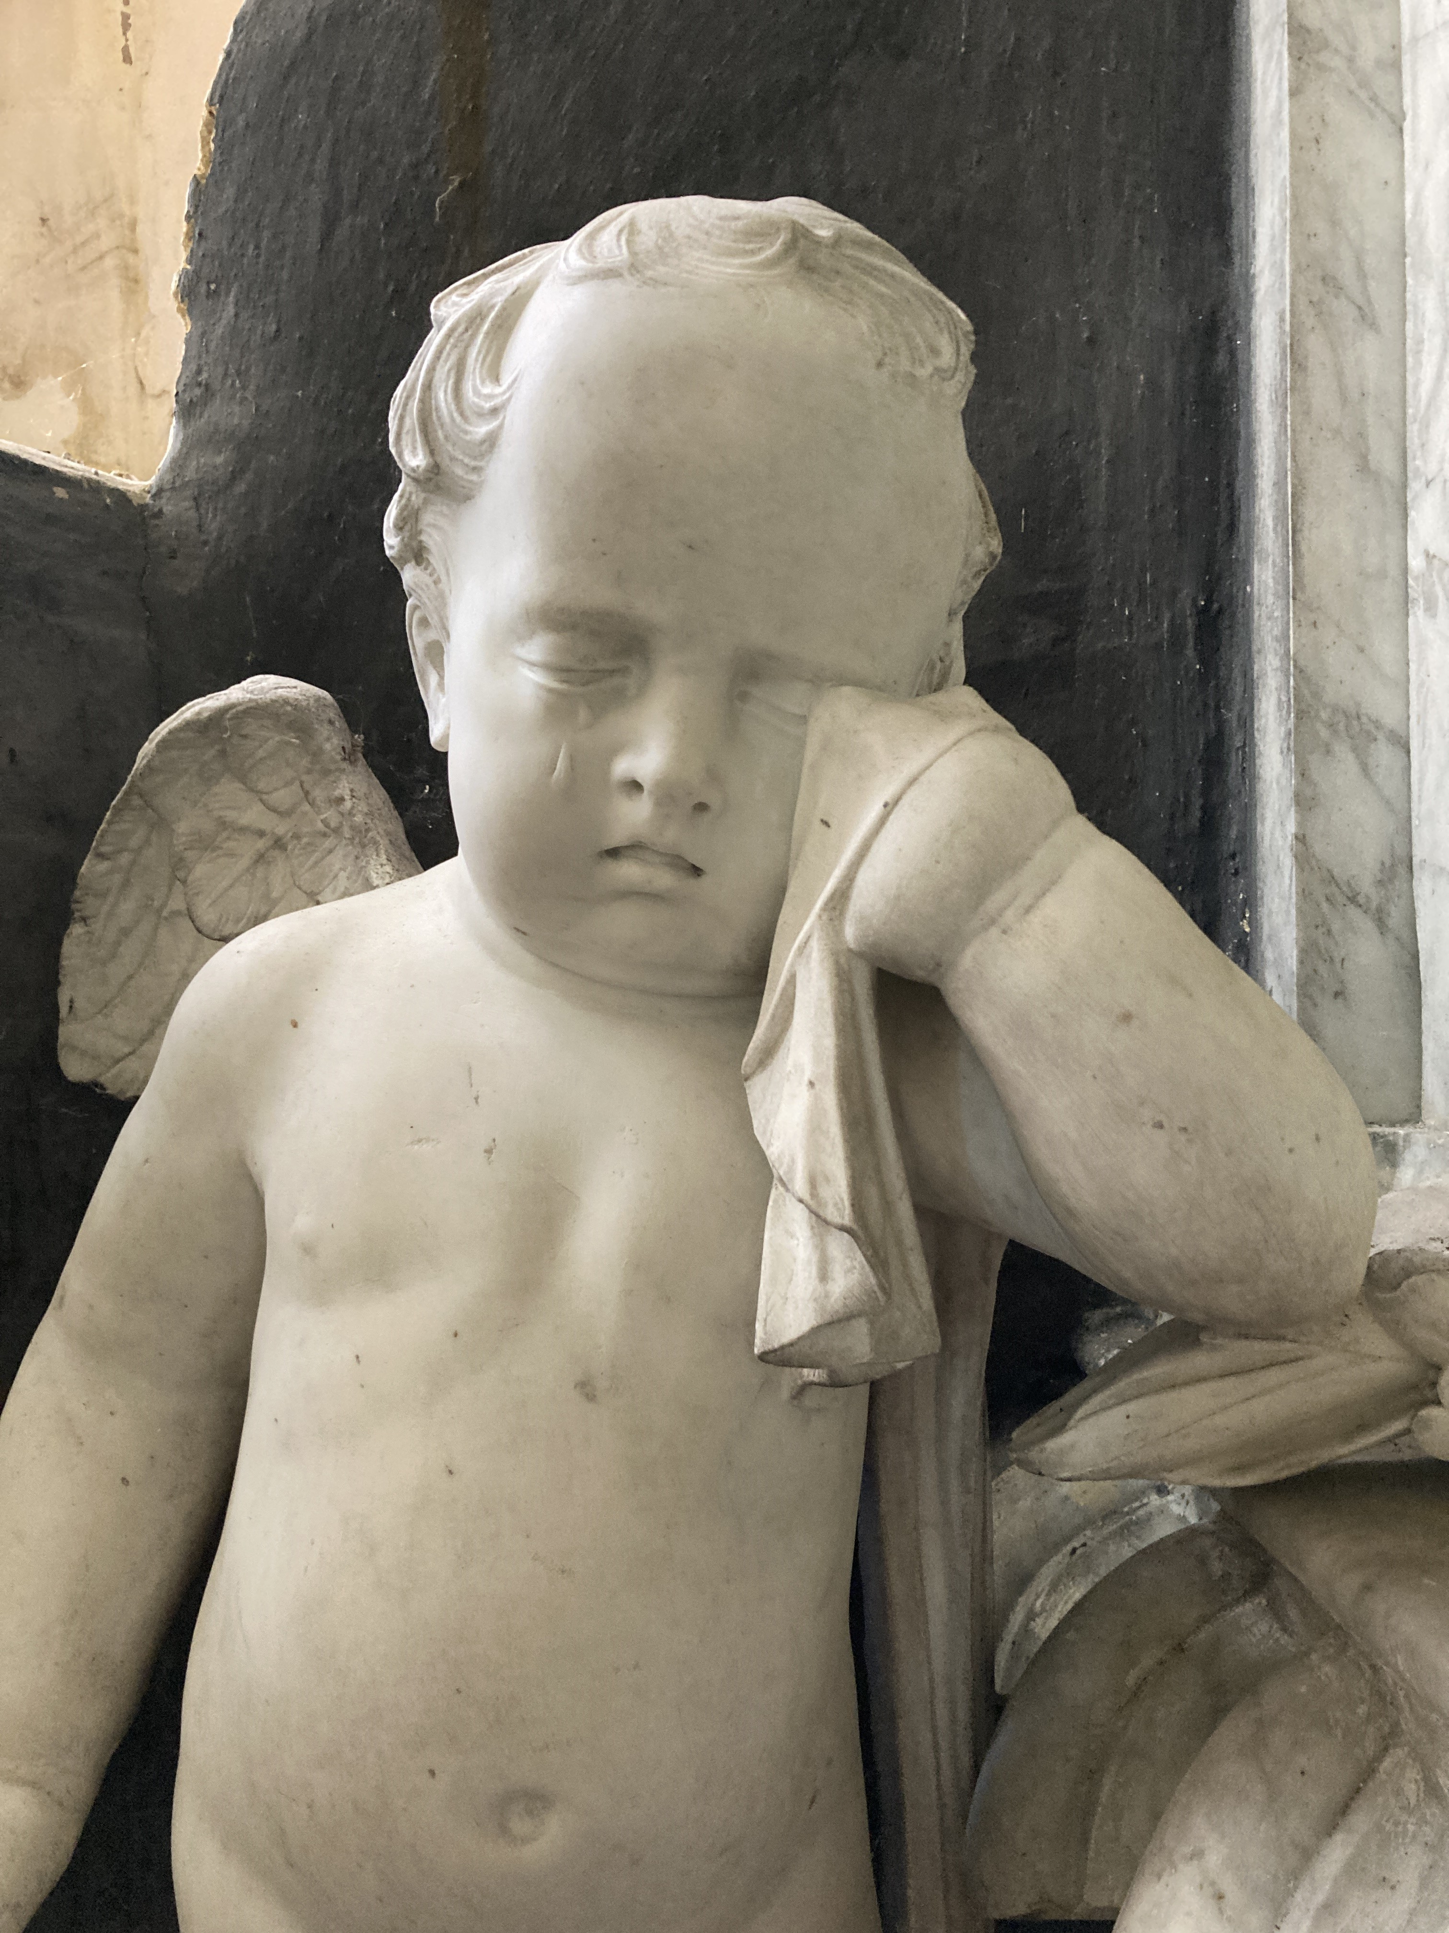
Part A - Current Report

Church Introduction and Statement of Significance
Current Use (bookings) and voluntary activity
Collection Review
Conservation Reports
Income, Expenditure and Balances
Local Community Officers Report

Part B – Survey

Results of our open survey conducted in 2020, canvassing all community contacts for feedback
on the current report

Part C - Community
Recommendations

Minutes of community meetings held to discuss opportunities, activities and plans for the church

Part D - Action Plan

Details of short, medium and long term actions agreed upon through Community Recommendations, assigned to community participants or Churches Conservation Trust staff

Version Updated March 2026

Introduction

The Churches Conservations Trust’s strategy is to empower and support communities to care for historic places of worship, for the benefit of all. A sustainable CCT church is well used by its communities, generates sufficient funds for the maintenance that keeps it in a good state of repair and is able to raise funds for specific repair and improvement projects. Local Community Officers facilitate this through their work with the community to co-create Church Plans.

Church plans are a living document which combines information on the church’s history, significance, maintenance and repair needs and the current use of the church, with feedback and recommendations from the community, and concludes with an action plan setting out agreed short, medium and long term actions to support the sustainable use and care of the church.
Part A - Current Report

Church Introduction & Statement of Significance

Although the church has a 13th-century origin, the oldest fabric still surviving in it is from the 14th century, namely the nave and the chancel. In 1614 the south chapel was added by Rowland Berkeley, a Worcester wool merchant and the owner of the nearby hall. The tower probably dates from the 17th century, and the porch was added during the following century. In 1857 a restoration was carried out by Henry Rowe. The church has been vested with the Churches Conservation Trust since 1987.

The church is constructed in grey lias stone with red sandstone dressings; its roofs are tiled. The plan of the church consists of a nave, and a lower and narrower chancel, with a chapel to the south of the chancel. At the west end of the church is a tower, which is embraced by the nave, and to the west of that is a porch. The porch is timber-framed, and it stands on a small brick wall. Above it is a two-light west window. The tower is in two stages above the nave roof. The top stage contains small square-headed louvred bell openings on each side, and it has an embattled parapet. In the south wall of the nave is a doorway with a window to the left. To the right of the door are a single-light and a two-light window, both with Decorated tracery. The north wall is correspondingly similar. In the chancel is a three-light Perpendicular-style east window dating from the 19th century. In the north wall of the chancel is a four-light mullioned and transomed bay window dating from the late 16th century, and a single-light window. The south chapel has an embattled parapet with pinnacles. In its west wall is a Tudor doorway, the south wall has two two-light windows, and in the east wall is a three-light window.

Both the nave and the chancel have plastered barrel roofs. The font consists of a round bowl on a round stem. The benches date from the 19th century and are carved with poppyheads. The pulpit is from the same period, it is polygonal and painted blue. The reredos is also from the 19th century, and hidden behind it are wall paintings from the 16th–17th century. The major features of the interior are the monuments. In the bay window of the chancel is a tomb chest behind railings dating from the late 16th century. It was intended for John Slade who died in 1597, but he was buried elsewhere. The space between the chancel and the chapel is occupied by a large monument to Sir Rowland Berkeley, who died in 1611, and his wife Katherine. It was possibly designed by Samuel Baldwin, and consists of two effigies on a tomb chest. At its corners are diagonally-set obelisks. The effigies lie under a coffered arch, carried on fluted Ionic columns, and at the top of the arch on both sides is an achievement. To the east and west of the monument are gates and railings that divide the chancel from the chapel.

Within the chapel is the tomb chest of Sir Robert Berkeley, who died in 1656; the chest carries an effigy in judge's robes, and also has an achievement. On the wall is a monument, attributed to James Hardy, to the memory of Thomas Berkeley who died in 1693, and his wife Anne, who had died in the previous year. There is a Baroque monument attributed to Grinling Gibbons to the memory of Robert Berkeley who died in 1694, and a wall monument with a sarcophagus, made by W. Stephens and Company, to another Robert Berkeley who died in 1804. On the walls there are three 19th-century hatchments, and in the chancel are 17th-century brass plaques in the floor, and 18th-century grave slabs. All the stained glass in the church dates from the 19th century and was made by Hardman & Co. The east window of the chapel depicts the Resurrection, the southeast window the risen Christ, and the southeast window contains figures of the Saints Robert and Catherine. In the north window of the chancel is a depiction of the Annunciation. There is a ring of four bells, all dating from the 15th century.

The churchyard wall, which bears the dates 1629 and 1714, is designated as a Grade II listed building.

Current use (bookings) & voluntary activity

All Saint’s currently enjoys permission from The Church of England for six Sunday services each year and four additional services on an occasional basis. During the last three years there has been an annual service held in June. Other events include concerts and private tours, as well as the learning event Half Term at Spetchley. Local bell ringers have used the church for ringing events, including an attempt at a full peal to celebrate CCT’s 50th anniversary.

Voluntary activity undertaken by volunteers includes:-

- Daily unlocking and locking
- Cleaning days
- Remittance of wall safe and service funds
- Planning and delivery of all bookings including services
- Ad hoc reporting of building change

Church Information
General Information:
Open Churches Policy status: | Open
Local Community Officer: | Tracy Genever
Current projects: | Not at present
Parking: | Nearby parking for Spetchley Park Gardens
Building services: | Electric lighting
Churchyard: | Not owned by CCT, maintained by the staff at the Park
Ring-able bells: | Yes
Organ: | None
Volunteering:
Key holder role: | Fulfilled
Key representative role: | Fulfilled (Remittances, CCT liaison, maintenance reporting)
Fundraising roles: | Vacant and necessary
Stewardship/events roles: | Vacant and necessary
Research, interp. & talks role: | Vacant and necessary
Cleaning schedule: | Regularly led by volunteers in accordance with CCT guideline
CCT Items:
CCT silver plaque: | Installed
CCT information board: | Installed, requires updating
Oak post: | Installed
CCT freestanding board: | Installed
Wall safe poster: | Installed, current
CCT A board: | Installed
Gift Aid envelopes: | Provided
Visitor book: | Installed
Welcome table: | Maintains stock of current leaflets
Children’s explorer cart: | Not at present
Children’s trail: | Not at present
Tourism/Marketing:
Nearby attractions: | Worcester attractions, Worcester Cathedral, Worcester Woods, Churchill CCT church
Social media presence: | Not at present
Images on CCT website: | One of four
Regular feature parish news: | Not at present
Events/Activity:
Services per year: | Occasional
Christmas memory tree: | Yes, unsponsored
Heritage Open Days: | Not currently
Ride & Stride: | Yes
Champing: | Not currently
Retail: | Not currently
Health & Safety:
Fire rated capacity: | 95
Seating capacity: | Not determined
Site plan: | Available
Roof alarm: | Not installed
CCTV: | Not installed
Individual item security measures: | None
Accessibility details: | Provided via website
Risk assessment general: | Current
Risk assessment fire: | Current
COSHH listing: | Current
Portable appliance listing: | Current
Security Audit: | Current
Pews: | Sound, no defects

Conservation reports

Annualised maintenance costs (Exclusive of VAT):  Annualised maintenance costs express the total costs of church maintenance divided by 25 years. Every forecasted cost which relates to the maintenance of this church over a period of 25 years is included. Any anticipated repairs are excluded. A list of typical maintenance tasks for any historic church, forecast over the period, is available to view at appendix 2. | £4,316.44
Routine maintenance costs (Per annum and exclusive of VAT):  These are included in the annualised maintenance costs and are the total cost of two maintenance visits per year. A list of the typical maintenance tasks for any historic church included in the twice-annual maintenance visits is available to view at appendix 3. | £552.00
Other maintenance costs total (Exclusive of VAT):  Additional maintenance needs discovered during twice-yearly maintenance visits, costed and listed individually below. | £3,600.00
- High level survey of the masonry | £1,800.00
- Repair of the steps | £450.00
- Exterior limewash | £1,350.00
Total short term repairs: Small scale items of limited cost which could be fulfilled with minimal fundraising. | £13,615.00
- Minor roof repairs | £3,500.00
- RWG | £4500.00
- Minor roof walling repairs | £5615.00
Total medium term repairs:  More expensive needs such as roof repairs and tower repairs which may require more involved fundraising and grant applications. | £13,950
- Window ferramenta repairs | £1,000.00
- Internal repairs to the tower walls and ceiling | £7040.00
- Repairs to underside of the nave roof | £5,910.00
Total long term repairs:  Items which are known to require works in the longer term but which are not essential in the near future. | £4995.00
- Carry out repairs to the walls and columns | £4995.00
Total desirable repairs:  Repairs which are not essential to the conservation health of the church but which might improve aesthetics or usability of the building. | £0.00
All cost figures are estimates, exclusive of VAT and professional fees.
VAT is charged at 20% of the total costs and can sometimes be recovered. Professional fees vary, but are either charged at an hourly rate or as a percentage of the total project cost. These are usually charged only on larger or more complex projects.

Income, Expenditure & Balances
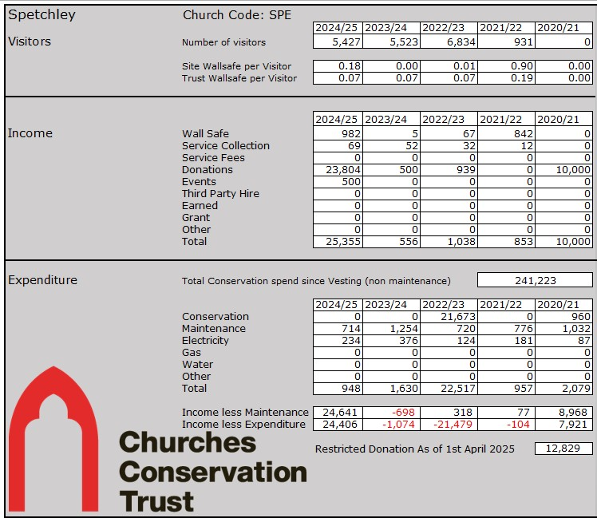

Income less annualised maintenance 2024/25 -£21,039.00

(Income from all sources, minus the annualised maintenance cost, as shown in the Conservation Report section above)

Local Community Officer’s Summary

This pretty and popular Worcestershire church benefits from very generous support from a small number of regularly active community participants who live at the adjacent Spetchley Park. Additional members of the community support the church well through cleaning days and attendance at events.

This is a church with high footfall and a good income, however, the Gardens are closed during the winter months and so visitors do not come.

Additional marketing could focus on historical societies with an interest in the history of the local area, including the Berkeley family, seeking bookings to tour the church alongside other popular Worcestershire venues. Voluntary effort towards research and interpretation products could facilitate encouragement of these bookings at the same time as enriching the visitor experience further.

The opening and closing regime at the church, is ably managed by local residents or staff at Spetchley Park Gardens at present.

Part B – Survey

Summary of consultation responses received by end August 2020

Following distribution of fifteen questions through our standard church plan questionnaire in summer 2020 to existing Churches Conservation Trust correspondents, (together with an invitation for correspondents to share the survey and associated Church Plan Part A), no response was received for All Saint’s Spetchley by the deadline of August 30th. An example of the survey is in appendix 1.

Part C - Community Recommendations

Spetchley Church Planning Meeting held 4th March 2026. Attending TG (Local Community Officer), Rev CB, Church wardens MH & HL, PCC representative and volunteer JB

Building

The church is looked after by the volunteers and the benefice assists with cleaning ahead of services. More assistance with cleaning would be welcomed. The church gets very damp in the winter months when it is closed up and this winter is smells particularly damp. Volunteers will aim to air the church on dry days to held with this.

The wall safe and collecting jars are emptied regularly by the volunteer and banked by the LCO.

Events

In 2025, the community held a very successful medieval graffiti tour day along with refreshments, during CCT Week. There was also the summer service in July. Both were well attended.

In 2026, the summer service will be on the 11th July. Plans for any other events are not ready yet.

Volunteers
The volunteer on site would very much like additional help with the cleaning of the church.

Spetchley Church Planning Meeting Held September 2024. Attending TG (Local Community Officer and 5 volunteers

Maintenance and repairs

The church is looking very well presented and the flowers, as always look beautiful. Many thanks to everyone who helps with these tasks. It was agreed that additional regular volunteers were needed to help with the cleaning of the church.

More Spetchley church leaflets are needed and the PCC has agreed to pay for this if the original PDF can be found.

The community were told by the LCO that repairs to the South door would take place during the months the Gardens were closed (November to end of March)

There has also been a significant legacy given to CCT for Spetchley Church.

A discussion was had regarding covering the cost of candles, flowers and printing of guides in the church and it was agreed that the collecting tin by the candles should be clearly labelled so donations there are for candles and flowers, rather than CCT.

The LCO agreed to bank the wall safe money regularly and any change from the CCT jar by the door which is emptied by JB.

Events

The annual summer service was held in July with refreshments (Pimm’s and sandwiches!) was well supported by the benefice.

There was Christmas Cheer service last December but it is a lot of work for the volunteers so may be on alternate years. Will look at a Christmas flower arranging demonstration in the Cart Shed as this has been popular in the past. The community are also considering a Spring music event and a joint history event with Churchill church in the spring.

Future event idea: Tour of church showing the medieval marks such as those around the main doorway into the church. Previously BH, who is local and did work for CCT, has given a very interesting talk and has published a book ‘Magical House Protection – The Archeology of Counter-Witchcraft.

Spetchley Church Planning Meeting Held - December 2022, attending GS (Local Community Officer) et al.

Maintenance/Repairs

Scaffolding was erected last year for the restoration of the tombs etc, of water damage when the lead was taken from the roof.

The new lighting around the side of the chapel is outstanding as this has not been installed yet. A local community member has very kindly offered to pay for this work.

Events
The annual service is held in the summer.
Room on the estate could potentially be available for free, holds 80 people and could host events.

Detailed discussions took place and agreed that it would be great for the church to be used more for services and events.
Presentation by history expert about the church was also mentioned as a fundraising event.

Visitors

The church is very much promoted to visitors to the Spetchley Gardens Estate and therefore has a good number of visitors.

General Discussion

The community loved the article in the Pinnacle Autumn 2022 of the work done in the church partly due to J B's legacy.in the church.

Local volunteer has undertook Safeguarding in churches, the on line course was done as she- is on the PCC of White Ladies Aston & Spetchley.

This church benefits from long standing, very loyal and committed volunteers who also have a very good relationship with the onsite estate, who are also very supportive of the church.

Part D - Action Plan
Community Actions

Short term actions (to end Dec 2026)
- Ideas of one event in 2026
Medium term actions (to end Dec 2027)
- Try to recruit new volunteers.

Long term actions (to end July 2029)
- The church is surrounded by four villages – possible events to be held that would be of interest to people who live nearby, explore if community involved with the church can get them involved e.g. helping with cleaning, helping at events, etc.
- Investigate suitability of church for more regular religious use.
- Discuss potential for regular church related features, parish newsletter and inclusion of church updates in parish council meetings.
- Consider means for increasing footfall and consequent donations.

Actions completed (to end Feb 2026)
- Change label on candle collection box to include other items
- Look into holding a Christmas floristry demonstration on site
- Reprint church leaflets for the Spring 26
- Investigate if the local history expert is interested in hosting an event at the church about medieval house marks for June 2025
- The community very kindly organised for the lighting to be installed around the side of the chapel.
- Annual service was successful.
- The church was decorated for the Coronation of the King 2023
Local Community Officer Actions
Short term actions (to end Dec 2026)
- Put short item in Bowline newsletter regarding volunteer cleaners
- Bank any money held in wall safe and by volunteer at end of the Garden season.
Medium term actions (to end Dec 2027)
- Recruit cleaning volunteers to go around local CCT churches
- Organise regular meetings with the community.
- Engage in regular and on-going communications with the community, also support them as required.
- Work with the community to market the church in the area.
Long term actions (to end August 2029)
- Investigate suitability of church for hire to increase usage and income.
- Consider means for increasing footfall and consequent donations.
- Speak to the Gardens about how the church could be included in special events.

Actions completed (to end Feb 2026)
- Send pdf of church leaflet to JB for reprint.
- Repairs to the wall safe are on the CCT wall safe repairs list.

Appendix 1: Summer 2020 Questionnaire

This is the first of fourteen questions in the survey - thank you in advance for working through each one. First of all, we need to know if you're completing the survey on behalf of an organisation or writing in a personal capacity (If you're writing on behalf of an organisation, please use the text box to let us know which one. Thank you!)

Which church are you writing about? (Don't worry, you can complete additional questionnaires for other sites if you like!) Please state the location and dedication, as in 'Sapperton, St. Kenelm's'. Thank you.

People are involved with our sites in so many different ways. In your own words, please describe your relationship with the church building.

Some people are actively involved at the churches we look after together. If you're part of this group, tell us about your involvement. Cleaning, attending services and fundraising are just a few of the most frequent activities we share, but we'd appreciate as much detail as you might be happy to provide.

In your own words, and having reviewed 'Part A' of our church plan (sent to you by email with the invitation to this questionnaire), please describe a perfect outcome for our work together at the church. What would you like to see happen in terms of community involvement and other use of the building?

Bearing in mind the repair liabilities and running costs described in the report you've read, what challenges do you anticipate for a sustainable future at your church?

Thinking about local life away from the church, which other community projects or activities are you aware of that could combine with our work to protect the church for the future?

Here are two questions together... Could increased use of the church benefit the community? How would this increased use benefit the church itself?

What do you think are the most important conservation priorities at your church? For each or all of these priorities, please also let us know about any ideas you have for addressing them.

Income and expenditure for the church is detailed in 'Part A' of the report we sent you. Addressing conservation priorities will entail finding new ways to raise funds. Tell us about any ideas or opportunities you have identified for raising additional income at the church.

What do you think might be the best ways to get started with any fundraising activities you have suggested?
If you don't already, would you be interested and available to take part in future fundraising activity?
Almost done! We'd like to invite you to join us in a group discussion about the church later this year, either in person or through 'phone / video conference. Would you be willing to join the discussion?
Last question! Is there anything else you'd like to share about your interest in the church which we haven’t asked you already? Otherwise, thank you again so much for reflecting on the future of the church through your answers.

Appendix 2: Typical Maintenance Tasks Forecast For A CCT Church Over 25 Years
The list below gives examples of items that CCT needs to maintain in its churches. Some items on this list will not relate to this church but give guidance as to the typical items we cover. These estimations are based on the cost in 2020, please note we are not able to predict inflation costs and therefore these are not included.
A specific report is created for each church every nine years by an experienced and trained building inspector. This details the repair needs of the building and lists the repairs required according to their priority. Please contact your Local Community Officer if you wish to see this report.

Item | Method & Purpose | Cycle/ Yrs | Estimated Cost per visit (present day levels) | Cumulative Estimated Total Cost After 25 Years (2020 values)
Drains, rodding | Below-ground drains can be blocked by debris which stops the rain water dispersing properly and potentially leading to water backing up and overflowing. To prevent this they require rodding and cleaning even ten years. | 1 | £ 39.00 | £ 975.00
Soakaways, inspection and clearance of silt build-up | Soakaways consist of a large pit filled with gravel of varying sizes which act as a filter to allow rainwater to slowly seep into the surrounding ground. Over time material carried into the soakaway in the rain water fills in the gaps and slows the rate of dispersal which can lead to water backing up and potentially damaging or even flooding the church | 10 | £ 600.00 | £ 1,500.00
Mansafe hatchway system | Man safe systems are steel cables or anchor points which are fixed to the roofs of churches to allow people to safely access and work on the roof. As these systems are used for safety it is a legal requirement that they are tested every year for loose fittings or damaged cables. | 1 | £ 360.00 | £ 9,000.00
Lightning conductor testing | Lightning conductors are required to be checked every three years to make sure that they are still performing correctly and will be able to disperse a lightning strike effectively. Metal thefts have often targeted lightning conductors and they may need replacing. | 3 | £ 480.00 | £ 4,000.00
Organ maintenance | Organs are complex machines built using numerous natural materials which can be damaged by moisture, heat and animal attack. It is recommended that organs are checked every year to carry out minor repairs and to be re-tuned as required. Regular servicing can also reduce the likelihood of large unexpected repair bills. | 1 | £ 140.00 | £ 3,500.00
Fire extinguisher inspection | Fire extinguishers servicing checks that the fire extinguishers are functional and maintaining adequate pressure for use in an emergency. Note the CCT only provides fire extinguisher in churches which are either stewarded, used for Champing™ or have significant timber items. | 1 | £ 166.00 | £ 4,150.00
Electrical periodic inspection testing | Electrical tests ensure that the electrical system of the church is both safe and fully functioning. The test will check all elements of the system and highlight any concerns. | 5 | £ 350.00 | £ 1,750.00
Replacement of electrical fittings | As items are highlighted as faulty through periodic testing and maintenance visits they will need to be replaced. | 15 | £ 1,500.00 | £ 2,500.00
Replacement of lamps | General wear and tear - Bulbs require regular replacement. Note LED bulbs will be used where possible | 2 | £ 250.00 | £ 3,125.00
Heating installation, servicing | Annual servicing of the heating system to ensure the efficiency and safe working order of the boiler etc. | 1 | £ 384.00 | £ 9,600.00
Roof alarm, servicing | Roof alarms require annual servicing to check that the system is in good working order and to replace minor parts such as the batteries in sensors. | 1 | £ 316.80 | £ 7,920.00
Rainwater goods, redecoration | All external rainwater Goods (RWG) require redecoration as they are in exposed locations and are exposed to significant amounts of water. The redecoration significantly extends the lifespan of the RWGs and ensures that they are working correctly and are securely fixed in position. | 7 | £ 1,560.00 | £ 5,571.43
Internal & external ironwork redecoration | Redecorating the ironwork prolongs the life of the item and improves the aesthetic of the church. The redecoration of ironwork also provides a good opportunity to inspect the item for damage. | 7 | £ 1,500.00 | £ 5,357.14
External joinery, redecoration | Redecorating external joinery prolongs the life of the item and improves the aesthetic of the church. The redecoration of ironwork also provides a very good opportunity to inspect the item for damage. | 7 | £ 1,875.00 | £ 6,696.43
Window repairs | Minor repairs to the windows such as broken panes of glass, replacement of glazing bars, mortar repairs or lead work repairs are important to exclude the weather and birds and other animals. | 5 | £ 350.00 | £ 1,750.00
Bell maintenance | Bells require ad hoc inspection and minor maintenance to fixtures and fittings | 5 | £ 235.00 | £ 1,175.00
Condition inspection report, all specialists | We have a 9 yearly architect or surveyors inspection plan. When the survey is undertaken all elements of the church will be inspected and a prioritised plan for all required repairs will be created. | 9 | £ 450.00 | £ 1,250.00
Roof overhaul | Roofs require constant minor maintenance with a major overhaul every seven years | 7 | £ 2,500.00 | £ 8,928.57
Clock maintenance | An annual service of the clock with minor repairs and checks to ensure good timekeeping | 1 | £ 140.00 | £ 3,500.00
Tree inspection | A five yearly inspection of all the trees in the churchyards we are responsible for to check for defects and enable us to plan for any required works. | 5 | £ 225.00 | £ 1,125.00
Churchyard maintenance | Grass cutting and minor trimming of plants and bushes etc. | 0.5 | £ 200.00 | £ 10,000.00
Overheads | Office costs to support maintenance planning etc. | 1 | £ 20.00 | £ 500.00
Staff Costs | Staff costs incurred in preparing the required inspections and reports | 1 | £ 97.00 | £ 2,425.00

The total cost over 25 years for this example of a typical church is £107,598.57 (exc. VAT)

The average yearly cost for this example of a typical church is £4,303.94 (exc. VAT)

Appendix 3: Typical Maintenance Tasks Forecast - (Twice-Annual Maintenance Visits)

Item | Method & Purpose
Gutters, downpipes and gully clearance | Gutters, hoppers and downpipes are easily blocked by leaves and debris both windborne and dropped by birds which can lead to overflowing and water damage to the building.
Roof, inspection & replacing slipped/missing slates/tiles | Over time some slates/tiles or the pegs/nails which hold them will reach the end of their useful lifespan. When this happens it will allow slates to move from their correct position which can let rain in to the building and potentially poses a risk to visitors as the slate/tiles can fall.
Vegetation, control of growth | Overgrown vegetation against walls and buildings can hold moisture against the building potentially causing damage and some plant species are invasive. Vegetation can also obscure the building hiding potential damage and can provide shelter for vermin such as mice.
Tower stairs & boiler room steps, sweeping | Leaves and other debris can build up on steps which could lead to accidents if people slip. Regular sweeping reduces the risk for potential accidents.
Principal steps and paths, clearance | Leaves and other debris can build up on steps which could lead to accidents if people slip. This is especially the case for churches with trees in the area. Regular sweeping of the steps reduces the risk for potential accidents.
Wall Safe, servicing | Servicing of the wall safe helps to ensure that the donations can be easily collected and also checks to ensure that there hasn’t been an attempt to steal from the safe.

Appendix 4: Typical Champing™ Arrangements and Related Income

Champing™ is the exclusive overnight hire of a church to visitors. Camp beds and chairs are set up inside the church, along with tea making provisions, battery lighting, and cushions and blankets to give guests a cosy stay.

Guests book online through the Champing™ website www.champing.co.uk and these bookings are related to local contacts so everyone knows when visitors are staying. A local member of staff sets out equipment for the night and removes all gear each morning. Guests have exclusive access to the church between 6.00 p.m. until 10.00 a.m. so visitors can enjoy the church during the day.

Champers don’t expect much in the way of facilities and understand that these are ancient buildings. For most churches we’ve installed eco-loos either inside or outside in wooden cabins. We don’t allow candles but provide battery lanterns and fairy lights. As most of our churches don’t have heating we only operate Champing™ between the end of Marchand the end of October, and we recommend Champers bring warm sleeping bags and extra blankets. We also supply bedding and breakfasts but this option isn’t available at all churches. Most Champers will eat out locally or may bring their own picnic.

For those churches without electricity we provide a gas camping stove and we also provide amply bottled water for Champers and all visitors to use.

Typically Champers are couples and families. Some of our churches are large enough to welcome groups of up to 16 people. We are dog-friendly, and child-friendly. Many Champers appreciate the history, architecture, and unique features of their surroundings, and come to learn about the building and its locale through this unique accommodation. We offer those staying for the first time a free CCT membership so they can learn more about our work and consider support for The Trust after their visit.
You can evaluate typical income which derives from Champing™ in the table below.

Church | 2017 | 2018 | 2019 | 2020 | 2021 | 2022
Langport, Somerset | £10,47 | £2,766 | £3,810 | £3,128 | £7,748 | £4,938
Emborough, Somerset | / | £2,024 | £1,378 | £2,625 | £5,270 | /
Chiselhampton, Oxfordshire | £10,156 | £2,696 | £5,864 | £1,705 | / | /
Wolfhampcote, Warwickshire | / | £3,001 | £2,214 | £1,624 | £4,763 | £5,924
Holme Lacy, Herefordshire | / | £4,369 | £4,759 | £1,004 | £7,501 | £4,144
TOTAL | £20,628 | £14,856 | £18,025 | £10,086 | £25,282 | £15,006

